systems

The best water systems for growing plants indoors
A NuStream Filtration, Inc. White Paper
By James W. Baker CEO, BS, MWS
Rev. B, June 2019

Many different plants are grown in indoor greenhouses and enclosed buildings.
In these facilities, the plants need light, air with oxygen and carbon dioxide, nutrition and high-quality water. The facility will need to plan for these factors but water quality is often overlooked.

This paper will present the best water quality for growth and the methods for achieving it.

Background and Typical Problems:
Water quality is different in each location, from time to time and based on the season. Water supplies come from reservoirs that have collected surface water runoff, from several different wells, from rivers or lakes or some combination of these. In other words, water is not just water. It is water plus what it has been exposed to and what it has dissolved. Some of the water quality issues that affect plant growth and health are pH, chlorine and fluorine levels, temperature, microbiological levels, oxygen levels, and electrical conductivity.
In addition to the “natural” pH of the water, municipal water plants. have increased the pH of their water supply to meet the EPA lead rule. This is because higher pH levels don’t dissolve lead as well as lower pH water. This is the reason many water systems are running pH levels as high as 9 to 10 pH which is not good for plants that thrive at 5.6 to 6.5 pH levels.
The water supplier also may increase the level of chlorine from time to time based on higher bacteria levels in the supply or when repairs are made to water mains.
The temperature of the water is also a function of the weather, the source, and how the water is stored. Most plants do better with water that is between 65 and 75 °F.
One problem for the grower is the proliferation of bacteria. The water, its temperature, and the added nutrition are ideal for bacteria growth. As bacteria floats in water (planktonic bacteria), it comes in contact with tubing and piping walls and attaches (Stissel bacteria). The bacteria builds a slimy extracellular matrix called biofilm. This biofilm restricts the flow in piping and tubing and will plug water emitters and other devices. Periodically, the entire fertigation system will need to be disinfected.
Dissolved minerals (ions) are indicated by the conductivity of the water. Conductivity above 400 micro Siemens ( 0.4 milli Siemens) may indicate contaminants that might cause plant problems such as leaf burn, spotting, and staining of plants.
Starting with a pure water system ensures a consistent feed formula with repeatable results for every crop cycle regardless of the source of water. Commercial monocrops may get by with surface water, municipal water, or well water but for a high-value crop such as cannabis, every input will affect the final value of the product.

Providing High-Quality Water:
There are three basic supplies of water for the plants:
A typical high-quality water and fertigation room on a municipal water supply is shown in Figure 1.
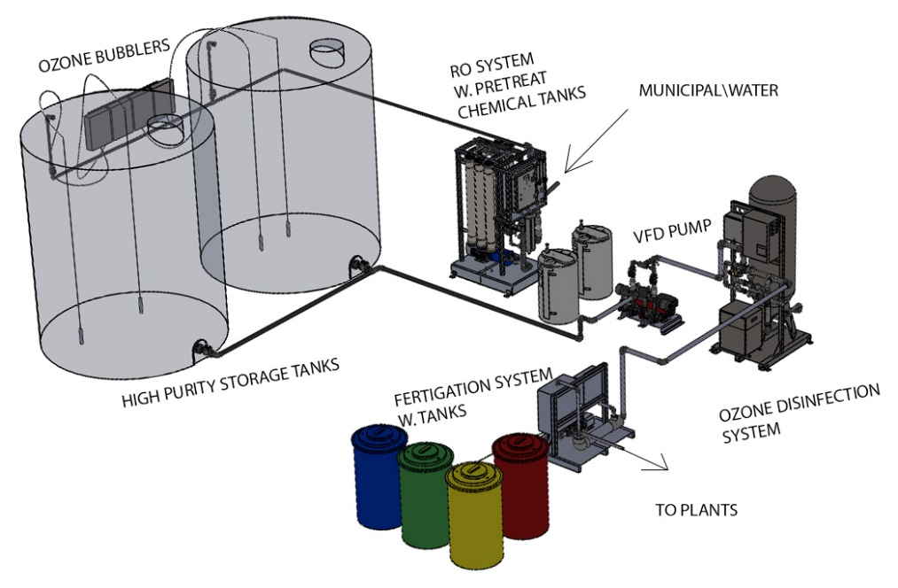
Figure 1A

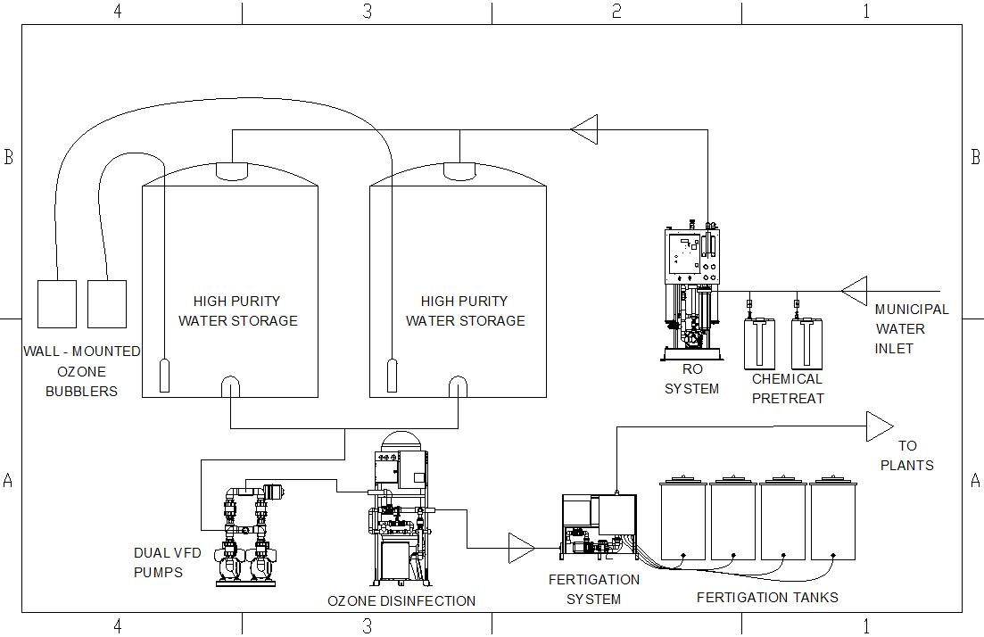
Figure 1B

A typical high-quality water and fertigation room on a well or lagoon water supply is shown in Figure 2.

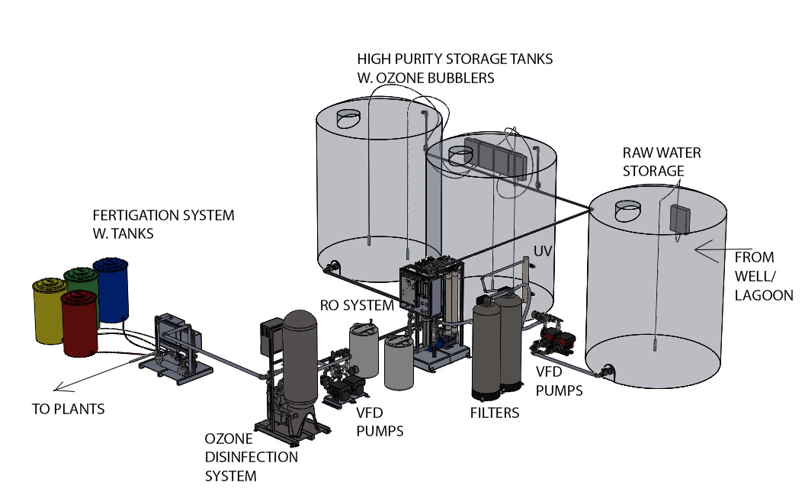
Figure 2A
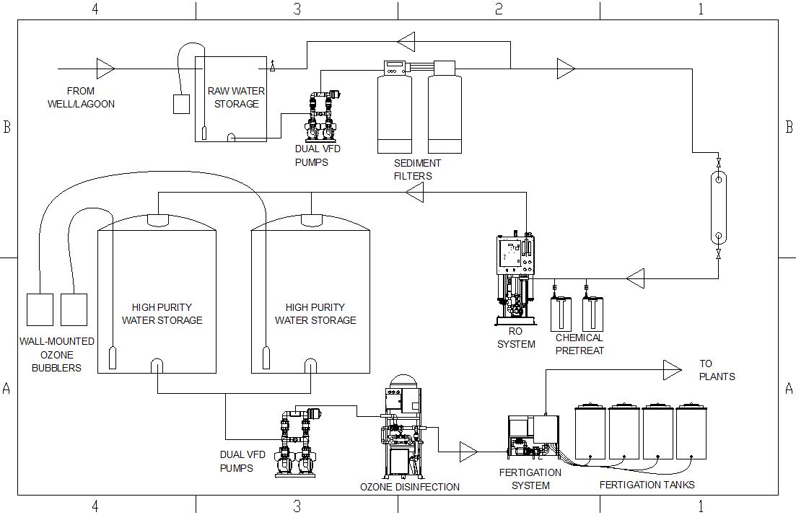
Figure 2B

Using these room layouts as a way to visualize the various components that make up the systems that provide high-quality water dependent on the source, I will describe their purpose and results.

Reverse Osmosis Systems:
RO removes over 95% of the inorganics and organics that are in the water by a very efficient and cost-effective process.
Some are concerned that the calcium and magnesium that are vital to the growth of plants will be removed. The molecules of calcium carbonate and magnesium carbonate that are found in source water are too large for plant root hairs to absorb through osmosis efficiently. Chelated calcium and magnesium as well as other beneficial biologicals that the plants can easily absorb with the RO water, are most easily accomplished by the fertigation process. Most nutrient manufacturer’s feed charts assume a base of pure water. By starting the feed formula with RO water growers are able to dial in exactly what they feed their plants, which changes a variable to a constant that makes watering and feeding plants dependable.
Other water contaminants like chlorine, fluoride, and alkalinity are also removed making a dependable and consistent water quality regardless of the source water.
Within the RO process, bicarbonates are broken down into water and carbon dioxide. The carbon dioxide is a gas that passes through the RO membranes reducing the pH of the RO water to between 5.5 and 6.5 which is perfect for the plants and eliminates the need to handle and determine the amount of acid to inject into the water.
Because the reverse osmosis process is removing the unwanted contaminants, there must be a waste stream. With today’s high efficiency RO systems, the flow rate of the waste stream is 25% of the feed water flow rate and the RO product flow rate is 75%.

Storage:
The RO product water storage tanks should be in the building where the water will be tempered to the room temperature of around 70 degrees - perfect for the plants. A good way to accomplish this is to store two days supply which will give the water time to temper.
Stored high purity water has no bacteriostatic capacity so it is recommended that a low-level ozone bubbler be installed in each tank. This will prevent bacteria, fungus, and algae from developing in the tank and will also help to mitigate biofilm development in the piping and watering devices. Ozone also degrades down to oxygen which is good for the plants.

Repressurization Pumps:
The tanks are atmospheric so the water must be pumped to the plants.
There should be two pumps for redundancy to supply the plants. These pumps should also be variable speed stainless steel pumps to adjust to the varying demands of the plant facility.

Ozone Cleaning and Disinfection:
Dissolved ozone is made on site and injected into the water. Ozone is a disinfectant 1000 times more effective than chlorine bleach without the negative residuals, ozone’s only by-product is oxygen. It can completely eliminate spores, bacteria, biofilm, viruses, mold, fungus and mildew.
Monitored dissolved ozone injection lets you disinfect a hydroponic or drip system with your plants still installed.
Ozonated water can also be sprayed directly on plants to kill spores, remove rust spots, fungus, powdery mildew, and bud rot. High levels of ozone can burn plants when topically applied to plants that need remediation, but it is a recoverable event.
When changing your fertigation solution, ozonate the fresh nutrient solution to disinfect everything and give your plants an oxygen boost. Ozone will oxygenate the root zones. Root zones are the area surrounding the plant roots.
Finally, between crops after harvest or transfer all equipment and piping should be flushed and ozonated to remove any biofilm or contaminants that may affect the next crop.

Summary
High purity water more than pays for itself by providing a method to improve plant production and growth.
High purity water provides a consistent method for repeatable results.

Bibliography:

Water Quality Association. Glossary of Terms. Lisle (IL) 1997
The University of Tennessee. Agricultural Extension Service. PB1617- Irrigation: Water Quality for Greenhouse Production.
American Water Works Association. Application and Engineering. Ozone In Water Treatment - Reference.
Maximum Yield Magazine. Cannabis Production. Ozone: An Indoor Garden Super Tool. Baron Wasteland, February 2014.

